Low Level Design(UPDATE Existing hotel)

Project Code | Team3
Project Name | Hotel Management System

Prepared/Modified by | Role | Date of Preparation
Shrikant Sutar | Software Engineer | 16/12/2013
Reviewed by | Role | Date of Review
Mrunalee Kothari | Software Engineer | 17/12/2013
Approved by | Role | Date of Approval
Uma M Ponniamman | Training Manager
Circulation List | amit.agarwal@igate.com, mrunalee.kothari@igate.com, keerthi.parthasarathy@igate.com, nidhi.shetty@igate.com, nikeeta.menon@igate.com, shrikant.sutar@igate.com, bhagyashree.vedpathak@igate.com | Version Number of the template:1.0
Version Number | 1.3

Table of Contents

1. Description Of The Unit 3
2. References 4
3. Dependencies / Assumptions 5
4. Class Diagrams 6
5. Sequence Diagrams 7
6. Design Components 8
6.1 List Of UI Components 8
6.2 List Of Design Classes 8
7. Re-Usable Routines/Components 9
8. Messages 10
9. Configuration Files 11
10. Crud Matrix Table 12
11. Data Mapping Matrix 13
12. Action Flow Matrix 14
13. Stored Procedures 15
14. Program Specification / Pseudo Code 16
REVISION HISTORY OF THE WORK PRODUCT 17

Description Of The Unit

The Update module is basically used by the administrator of the system, to update the existing hotel. It requires a pre-requisite that the administrator should be logged into the system.

On clicking the update button on the admin home page, the admin will be redirected to the Adminpage where list of all hotels is displayed and a ‘Modify hotel’ button against each hotel entry.The hotel which the admin wants to update should select that hotel to update.Once the hotel is chosen for updating, previously existing details about that hotel which are brought from the database are displayed in the text fields. The admin can then modify desired fields and then update the changes in the database. Modified fields are first validated, if valid the details are updated into the database after clicking “Save” button and on clicking “Continue” link, the admin is redirected to his page i.e AdminPage where he has can select other operations.

References

Reference | Description
Repository reference | https://IGTEBLRSVNTNG.igatecorp.com/svn/oct3_Team1
Class Diagram | /Project Documents/Design Documents/HLD/Class Diagrams
URS | /Project Documents/Requirements/Case Study/Ecommerce-grp1 and grp3.doc
UTP | Project Documents/Test Plan/UTP/Test Cases/ UpdateProduct/ UTP_UpdateProductModule.xls
DB Design | /Project Documents/Design Documents/HLD/DB Design/E-Commerce_GROUP_DBDESIGN.xls

Dependencies / Assumptions

Dependencies:
Update module depends on the Login module in such a way that, the admin is able to update a product only when he is logged in.

Class Diagrams

Class Diagram

Sequence Diagrams

Sequence Diagram
NA

Design Components

List Of UI Components
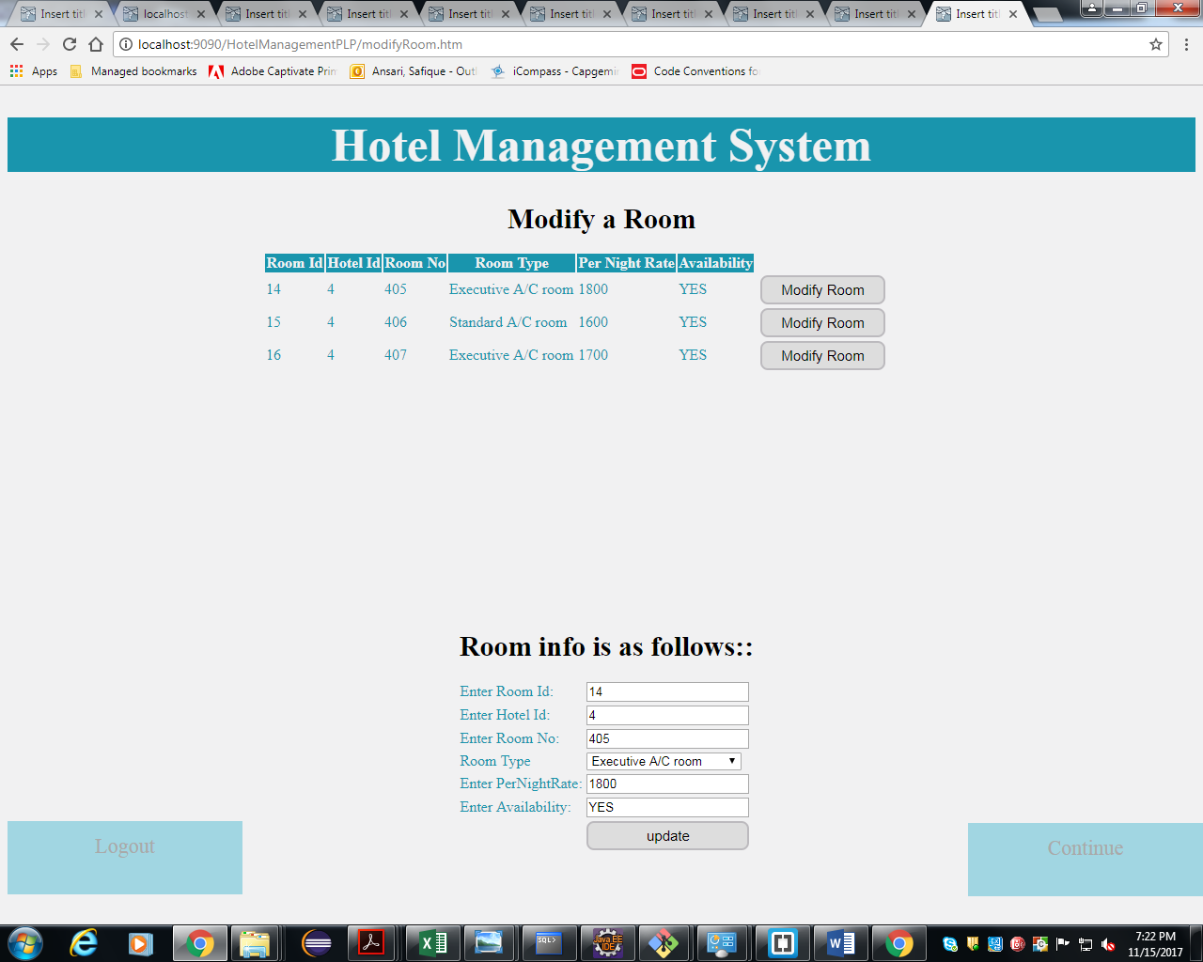

List Of Design Classes
Sr. No. | LLD Name | Class Name | Method Name | Method Description
1 | Update Module | Hotel | Appropriate getters and setters methods | Getters retrieve the property values and setters set the property values
2 | Update Module | HotelController | modifyHotel(@RequestParam("hotelId") int hotelId, Model model)  modifyHotelImpl(@RequestParam("hotelId") int hotelId,Model model,@ModelAttribute("hotel") @Valid Hotels hotel,BindingResult result) | Sets the model attributes ‘hotelId’,’hotel’,’list’ and send to modelHotelImpl jsp page.  It is called when ‘Modify Hotel’ button is clicked to merge new details of the hotel. It calls updateRoom(room) method of Service class.First previous details of Hotel are displayed and the admin will enter new details which will be saved in the database and message will be shown “Hotel Modified Successfully!!!”.
3 | Update Module | HotelServiceImpl | updateHotel(Hotels hotel) :void | Calls updateHotel(Hotels hotelDetails) of HotelDaoImpl class and returns the result .

4 | Update Module | HotelDaoImpl | updateHotel(Hotels hotelDetails) | Gets the details of the desired hotel depending upon the Hotel ID from database and Updates the new details of hotel into the database and returns boolean result to HotelServiceImpl .

Re-Usable Routines/Components

Re-Usable Routines/Components

- CSS files
- Javascript files
- Constant java class

Messages

#. | Type | Message Text
M1 | Error | Enter valid Pattern ex:tajHotel
M2 | Error | Enter valid Pattern ex:tajHotel
M3 | Error | Enter valid Pattern ex:AC
M4 | Error | It should be a number
M5 | Error | Phone no. must be 10 digits
M6 | Error | Phone no. must be 10 digits
M7 | Error | Range is 1-5
M8 | Error | It Should have five digits only
M9 | Error | Enter valid Email Ex:abc@gmail.com
M10 | Information | Hotel Modified Successfully!!!

Configuration Files

File Name | Path | Description
Web.xml | /HotelManagementPLP/WebContent/WEB-INF/ | To configure the bean properties.
Dispatcher-servlet.xml | /HotelManagementPLP/WebContent/WEB-INF/config/ | To configure the request mapping and view resolver.
jpaContext.xml | /HotelManagementPLP/resources/ | Add persistance annotation bean post processor to inject persistence context into entity manager factory.

Crud Matrix Table

# | Table Name | Create | Read | Update | Delete
1 | Hotel | N | Y | Y | N

Data Mapping Matrix

Sr. No. | Screen Label | Field Source | Field Type | Data Type | Max Length | Data Flow | Mandatory
1 | Enter City: | NA | Label | NA | NA | UI | NA
2 | city | Hotel.city | Textbox | Varchar2 | 10 | UI → D  D → UI | Yes
3 | Enter Hotel Name: | NA | Label | NA | NA | UI | NA
4 | hotelname | Hotel.hotel_name | Textbox | Varchar2 | 20 | UI → D  D → UI | Yes
5 | Enter Address: | NA | Label | NA | NA | UI | NA
6 | address | Hotel.address | Textbox | Varchar2 | 50 | UI → D  D → UI | Yes
7 | Enter Description of Hotel: | NA | Label | NA | NA | UI | NA
8 | description | Hotel.description | Textbox | Varchar2 | 50 | UI → D  D → UI | Yes
9 | Enter Average Rate per Night For the Hotel: | NA | Label | NA | NA | UI | NA
10 | avgRatePerNight | Hotel. avg_rate_per_night | Textbox | Number | 10 | UI → D  D → UI | Yes
11 | Enter Contact No: | NA | Label | NA | NA | UI | NA
12 | phone1 | Hotel.phone_no1 | Textbox | Varchar2 | 10 | UI → D  D → UI | Yes
13 | Enter Contact No2: | NA | Label | NA | NA | UI | NA
14 | phone 2 | Hotel.phone_no2 | Textbox | Varchar2 | 10 | UI → D  D → UI | Yes
15 | Enter Rating out of 5: | NA | Label | NA | NA | UI | NA
16 | rating | Hotel.rating | Textbox | Number | 1 | UI → D  D → UI | Yes
17 | Enter Fax: | NA | Label | NA | NA | UI | NA
18 | fax | Hotel.fax | Textbox | Varchar2 | 15 | UI → D  D → UI | Yes
19 | Enter Email: | NA | Label | NA | NA | UI | NA
20 | email | Hotel.email | Textbox | Varchar2 | 15 | UI → D  D → UI | Yes
21 | Save | NA | Button | NA | NA | UI | NA
22 | Logout | NA | Link | NA | NA | UI | NA

Legend
D → UI (Database to User Interface)
UI → D (User Interface to Database)
UI (User Interface Only)

Action Flow Matrix

Sr. No. | Action | Description | Process
1 | On click of “Modify Hotel” button | Allows the admin to enter the new details of the existing hotel | The admin enters new details of the hotel in the form and presses ‘Update’ button
2. | On click of “Update” button | Allows the admin to update the new details into the database. | The admin stores newly updated details of the hotel into the database and it navigates to the same page with the message “Hotel Modified Succesfully !!!” on the top.
3 | On click of “Continue” link | Admin is navigated to the Admin Page | On clicking of “Continue” link the admin navigates to the Admin Page where he can perform other operations.

Stored Procedures

# | Stored Procedure Name  (with Description) | Input/Out Parameters | Type | Size
1. | N/A | N/A | N/A | N/A

Program Specification / Pseudo Code

<ACTION: Modify Hotel_CLICK >

Pseudo Code:
- Client Side Scripting:
None

- Server Side Scripting:
BEGIN
Call modifyHotel(@RequestParam("hotelId") int hotelId, Model model) in Controller class
BEGIN
Call viewAllHotels() from HotelService of service layer
BEGIN
Call viewAllHotels() from HotelDao of dao layer.
BEGIN
Query is created by entityManager to view hotels.
Return Hotel List
END
Return Hotel List to service layer.
END
Return Hotel List to presentation layer.
END

END

<ACTION: UPDATE_CLICK >

Pseudo Code:
1. Client Side Scripting:
IF validation error occurs
Print error messages against each row from (M1-M10)

2. Server Side Scripting:
BEGIN
Call modifyHotelImpl(@RequestParam("hotelId") int hotelId,Model
model,@ModelAttribute("hotel") @Valid Hotels hotel,BindingResult result) in Controller
class in presentation layer.

BEGIN
Call viewAllHotels() from HotelService class in Service Layer
Call updateHotel(Hotels hotel) in Service Layer
BEGIN
Call viewAllHotels() from HotelDao in presentation Layer
Call updateHotel(Hotels hotel) in presentation Layer

BEGIN
Query is created by entityManager to view hotels.
Return Hotel List

Query is created by entityManager to update new details
IF validation error occurs
Print error messages against each row from (M1-M10)
Save new details in database
END
Return Hotel List to Service Layer
END
Return Hotel List to Presentation Layer
END
Navigate to same screen page with message M10
END

14. 2 <ACTION: Continue_CLICK>

Pseudo Code:

- Client Side Scripting:
None

- Server Side Scripting:
BEGIN
Call redirectToAdmin() in HotelController class
Return to Admin Page

END

REVISION HISTORY OF THE WORK PRODUCT

# | Date | Version # | Section Changed | Details of changes made | Approved By
1 | 16/12/2013 | 1.0 | LLD prepared | NA | Uma M Ponniamman
2 | 17/12/2013 | 1.1 | List of Design classes(6.2) | Name of the controller is modified to EshopController | Uma M Ponniamman
3 | 18/12/2013 | 1.2 | 6.2,10 | Added a method getSubCategoryList() | Uma M Ponniamman
4 | 24/12/2013 | 1.3 | Configuration files,UI Components | Paths of the configuration files is updated and UI components(Screen Shots) added. | Uma M Ponniamman

